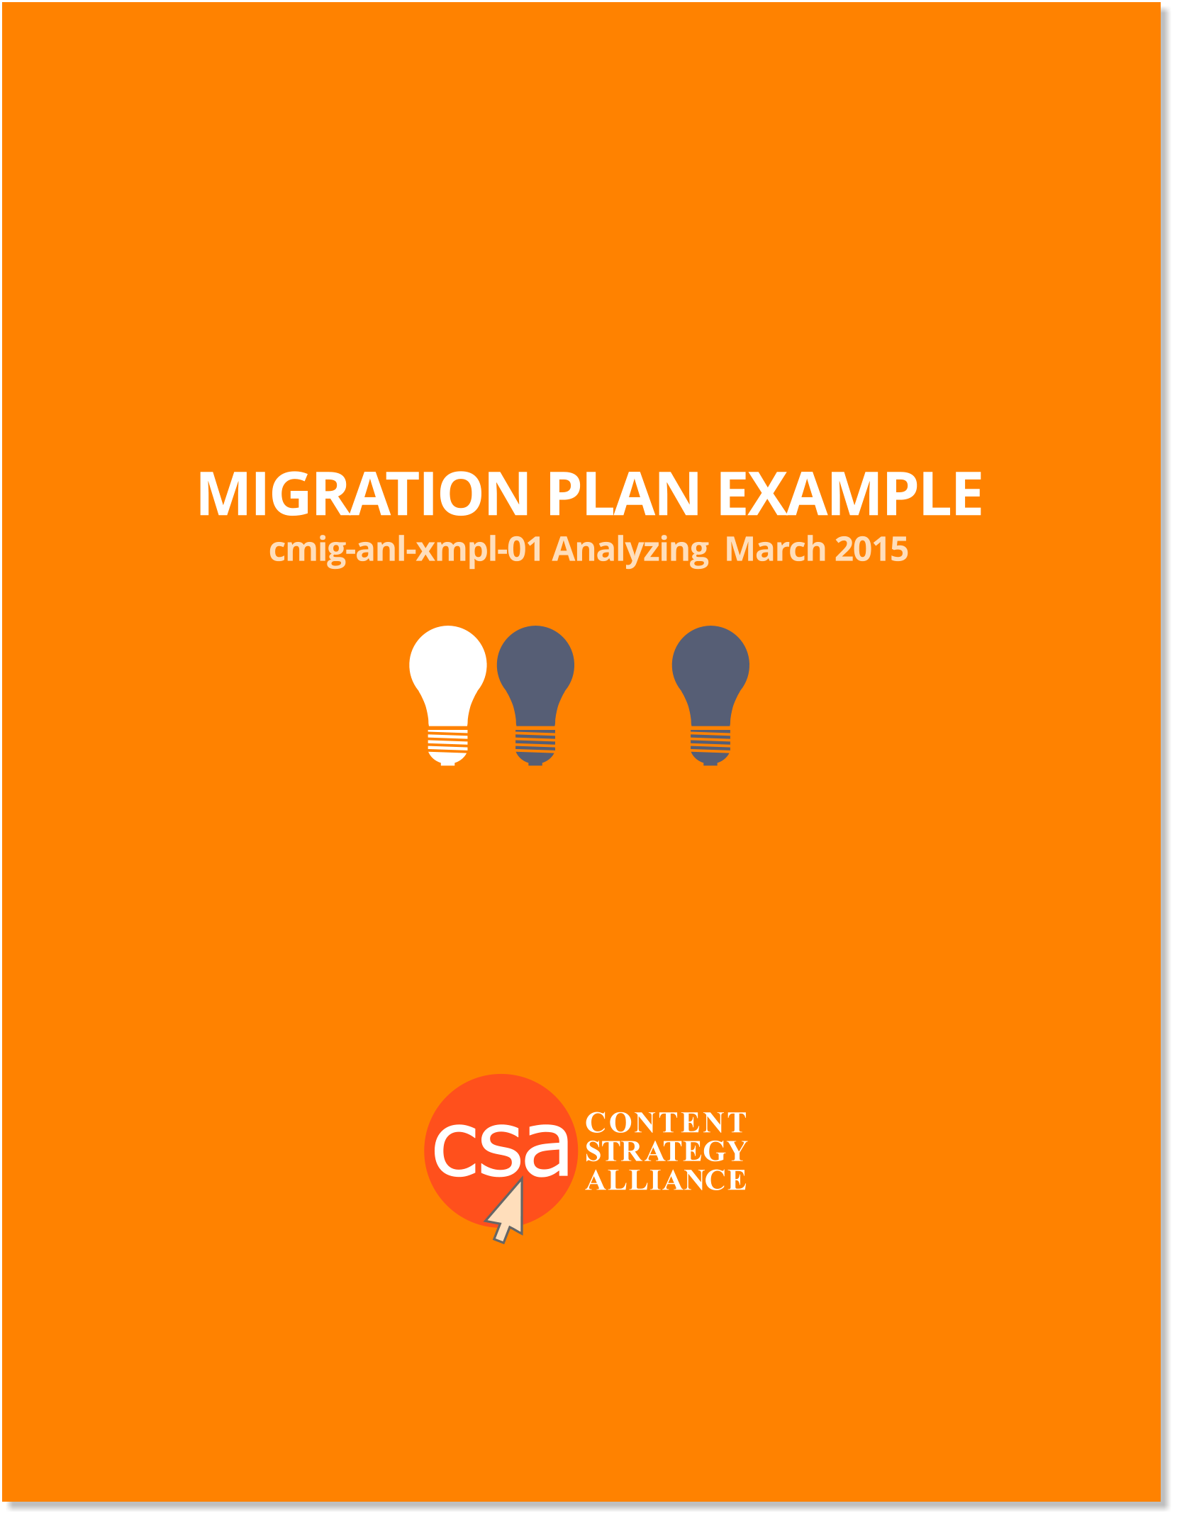
MIGRATION PLAN FOR COMPANY X
Table of Contents

Part One: Introduction
- Document objective and scope
- Strategic approach
Part Two: Inputs into Migration
- Current state analysis
- Content inventory and audit process
- Future business needs and considerations
- Ownership and content scope
- Content Sources
Part Three: Future State
- Content types
- Templates and modules
- Content organization and priorities
- Taxonomy and requirements
- High-level recommendations
- Conceptual content or domain model
- Mapping exercise and approach for existing to new content
- Gaps between existing, current state and future state/plan & approach
Part 4: Migration approach
- Recommendations for migration
- Staffing model for migration
- Planning for content migration
- Proposed process for content migration

© Content Strategy Alliance, 2015

PART ONE: INTRODUCTION
Document objective & scope
Agency and Client have partnered to do a redesign of Client's website. This document outlines the scope of the migration of content from the old CMS to the new one.

Strategic approach
Ensure that only current and useful content is migrated.

Part Two: Inputs into Migration
Current state analysis
Content currently consists of static HTML, PDFs, jpgs, Flash files, videos and app files. There is a lot of outdated content. There are about 4000 pages right now.

Content inventory and audit process/evaluation criteria
- The new site will be less content heavy and will focus on multi-media content and to-the-point text.
- Flash files should either be converted to another format or deleted.
- Content will be evaluated as: edit, keep or delete.
- Outdated content should be deleted.
- Press releases older than one year will be deleted.
- All PDFs should be evaluated by date and usefulness.

Future business needs and considerations
Content should be mobile friendly.

Ownership and Content Scope
The content strategy team will evaluate the content and decide what content will be migrated. The development team will migrate the content.

Content Sources
Press releases (70% dynamic), PDFs (dynamic and manual link fixing), ASP apps (embedded in the CMS, images (linked to the current server and will be migrated last), and videos (will be maintained on the existing file server, YouTube).

Part Three: Future State
Content types
Content currently consists of static HTML, PDFs, jpgs, Flash files, videos and app files.

Templates and modules
The content strategy team will work with developers to determine the type and number of templates and modules needed.

Content organization and priorities
- In Phase 1, Agency content strategists will deliver a matrix of content to be migrated. Developers will determine how many existing links can be re-used.
- In Phase 2, Agency will migrate 2000 pages to the new CMS. Focus will be on migrating page types (to be determined by content strategists and developers) that will be less prone to errors.
- In Phase 3, Agency will migrate the remaining pages (anticipate lower than 4000 pages after the audit) and videos. (Since videos are stored on YouTube, only video links, not the actual videos, will be migrated.)
- Agency will utilize the Kapow Katalyst tool to automate the migration. Some content will be manually migrated.

Taxonomy and requirements
Dublin Core will form the basis for the metadata. A taxonomy schema has been created by Agency and approved by the Client. Currently, the schema is stored in the old CMS. It will be migrated to the new server at a to-be-determined time.

High-level recommendations
- Only authors and publishers should have permissions to add and publish content in the server.
- Agency suggests that edits be made during low-traffic time slots.

Conceptual content or domain model
The content strategist and taxonomist have created these. Please see Domain Model Document.
Mapping exercise and approach for existing to new content
- Before the migration, a mapping of old pages to the new CMS will be developed and documented by agency content strategists in a content matrix.
- New content will be added to the content matrix after approval by Client.

Gaps between existing, current state and future state/plan and approach
- Previously there was no established tagging strategy or governance. Agency will develop this.
- The content strategists have created a gap analysis. Please see Gap Analysis Document.
Part 4: Migration approach
Recommendations for migration
Initially focus on migrating page types that are consistent enough to be less likely to create errors.

Staffing model for migration
Staff needed: two content strategists, project manager and four developers.

Planning for content migration
A robust content tagging strategy is recommended so that content is appropriately tagged and indexed.

Proposed process for content migration
In Phase I, the Agency will migrate 400 pages of existing content to the new CMS. This will be completed through a combination of dynamic and manual methods. Content migrated will include html pages, images and PDFs.

