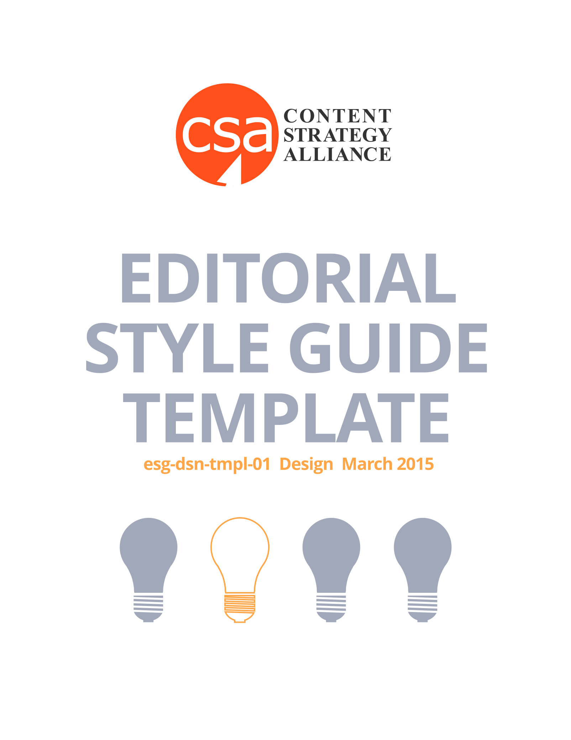

Contents
Grammar 2
a) Punctuation 2
b) Capitalization 2
c) Abbreviations 2
d) Names 2
i. People 2
ii. Titles 2
iii. Places 2
iv. Companies 2
v. Other 2
e) Sentence, paragraph, article length 2
f) Spelling 2
g) Style Guides 2
Voice & Tone 3
a) Tone (conversational, irreverent, objective, educational, etc.) 3
b) Voice (execution of the content) 3
c) Word complexity 3
d) First, second or third person 3
Content 4
a) General Copy 4
b) Interviews 4
c) Infographics 4
d) Product Descriptions 4
e) News/Press Release 4
f) FAQs 4
g) How-To Articles 4
h) Video Content 4
i) Audio Content 4
j) Miscellaneous 4

Grammar

Punctuation

Capitalization

Abbreviations

Names

People

Titles

Places

Companies

Other

Sentence, paragraph, article length

Spelling

Style Guides

Voice & Tone

Tone (conversational, irreverent, objective, educational, etc.)

Voice (execution of the content)

Word complexity

First, second or third person

Content

General Copy

Interviews

Infographics

Product Descriptions

News/Press Release

FAQs

How-To Articles

Video Content

Audio Content

Miscellaneous

