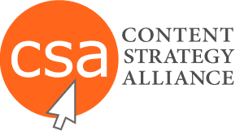 | Example Name |  |  | ID & Version |  | Phase |  |  | Creation Date
 | Content Map |  |  | cmap-anl-xmpl1-01 |  | Analyze |  |  | March 2015
Persona | Lifecycle Stages
Noreen Smith  Marketing Manager | Awareness  Or  Discovery |  | Interest  Or  Research |  | Desire  Or  Prospecting |  |  | Action  Or  Opportunity |  | Post-Purchase  Or  Consumer Advocate
 | Content examples for one persona
Type of Buyer:  Needs to buy new software for her company | • Industry blog  • Social media  communities  • General how-to  videos  • Industry white  papers  • General  purpose  eBooks  • Advertising  • Trade shows | • Company blog  • Overview  brochure  • Specific  how-to videos  • Best-practices  white papers and eBooks  • Webinars |  |  | • Product/service  videos  • Webinars - specific  • Product/  service brochures  • Limited product trial  • Online vendor demo  • End user testimonial  videos  - Case study white papers  • Vendor comparisons  • Personal emails |  | • Product/service  videos  • Webinars - specific  • Product/  service brochures  • Limited product trial  • Online vendor demo  • End user testimonial  videos  - Case study white papers  • Vendor comparisons  • Personal emails |  |  | • Upgrade offers  • Onboarding  documentation  • Customer  satisfaction  survey  • Customer  retention  communications

